Learning and development (L&D) is a systematic process to enhance employees’ skills, knowledge, and competency, resulting in better work performance.
L&D is a core HR function and a significant part of an organization’s overall people development strategy. It plays a key role in attracting and retaining talent, enriching company culture, and engaging employees.

What is the difference between learning and development?
Both learning and development are essential in helping employees grow and succeed, but they have distinct purposes.
Learning in the workplace is concerned with the acquisition of knowledge, skills, behaviors, and attitudes that lead to improved job performance. The process of learning takes place through various activities, such as seminars, conferences, hands-on experimentation, and reading articles or books.
Development is the broadening and deepening of knowledge in line with one’s individual long-term professional goals. It aims to grow job-related abilities to expand one’s potential for new opportunities in the future.
Activities that encourage development include leadership training, mentoring, coaching, job shadowing, and stretch assignments. Development is typically something an employee chooses to do rather than being required to.
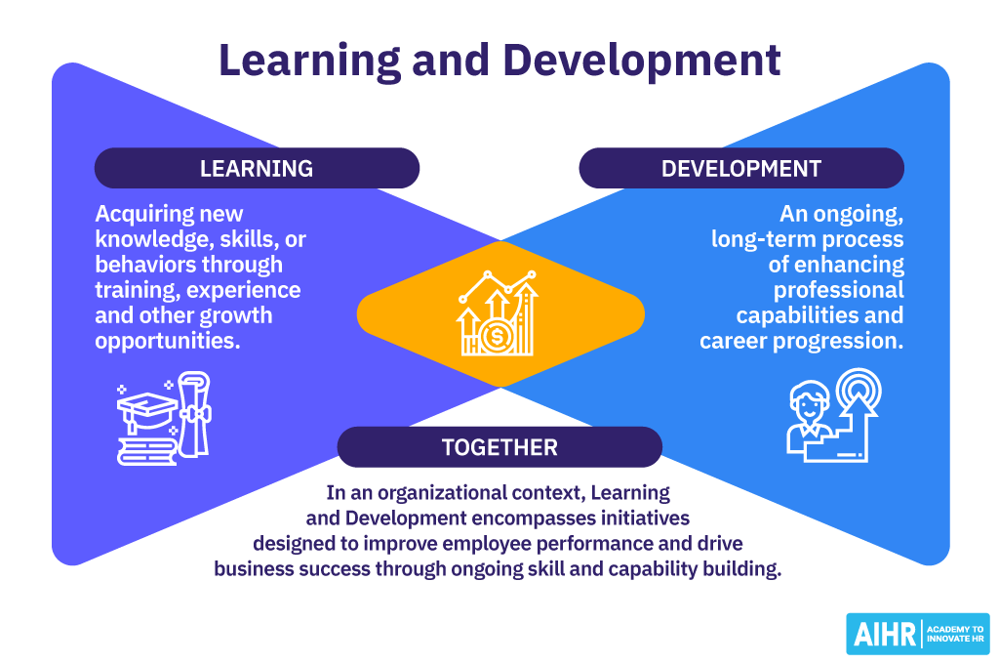

What is the difference between learning and training?
While the terms “learning” and “training” are often used interchangeably, in the world of L&D, they are two separate approaches.
Learning is the process of absorbing and retaining information that takes place over time. It expands one’s viewpoint and knowledge base for immediate application, as well as preparation for future endeavors.
Training is an instruction event for a specific skill or task that employees need to learn for a work scenario. It can take place on-site, off-site, or online and is typically aimed at groups of employees. For example, employee training can include teaching teams about a new product, how to respond to customer inquiries more efficiently, or how to use work equipment safely.

